The Bavaria Vision 46

EUR 770,000

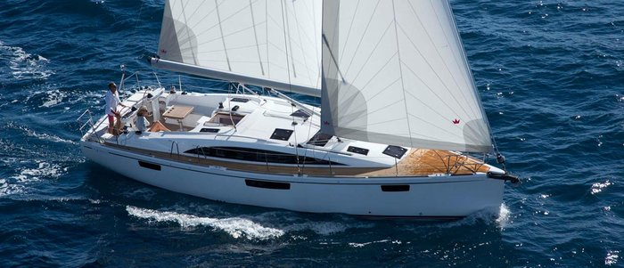

## Asking price: **EUR 770,000**

## Built: **2019, New England, Greater Boston**

## Length: **59.2m (290.6ft)**

## Cabins: **3**

## Berths: **6**

# Description:

# Life on the water should not remain a mere vision.

### Enjoying life on the water simply should not remain a mere vision. A VISION 46 makes this a reality. This yacht is made for people who want to stay on board for long periods of time without compromising any luxuries – at least, not any which are technically possible on a yacht. The VISION 46 has space for everything you like to have with you when sailing in both the two cabin and three cabin versions.